Cross platform assignment 1 for statement 2 : Medicine Project

Architecture of the system

Group members involved : **Group 55**

|  |  |  |
| --- | --- | --- |
| BITs id | Student Name | Contribution in project assignment |
| 2021mt12065 | Karthikeyan | Contribution 100% |
| 2021mt12377 | Akash Gautam | Contribution 0 % |
| 2021mt12213 | Shalini Roy | Contribution 0 % |

User story 1.1 : Customer landscape page

Login page

Book appointment with doctor

Book appointment for lab

Order medicines

Number of transactions

User story 1.2 :

Order medicines

Data will be fetched from backend API and project in JSON format

Architecture diagram :

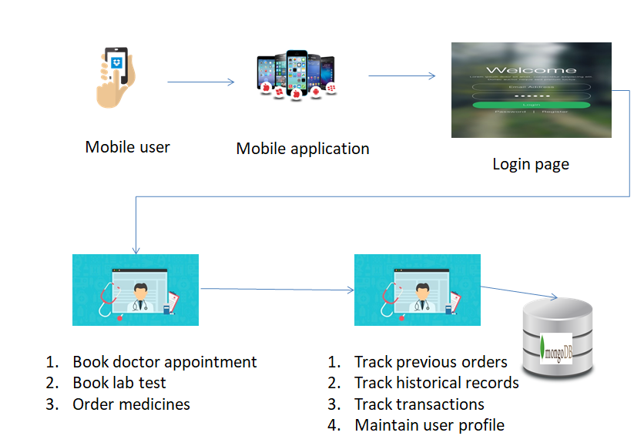

Software requirement:

1. Android studio development toolkit ( version 2021.3.1.17 for windows )
2. Mobile simulator
3. Flutter language
4. Dart language
5. Nodejs
6. MongoDB
7. Git 2.38.1 64 bit version for windows ( source : https://git-scm.com/download/win)

Project Output

<https://github.com/Karthikeyan12065/MedicineProject.git>

Project Screenshot

